**Topic**: State of the Sun

**Rationale**: Providing the user an opportunity to explore the “good” and the “bad” side of the sun across the US at a state-level. The primary focus is the “good”: solar project completion by state and associated metrics, including visualization of correlations by metric (e.g., system size vs. cost). The “bad” component is a review of skin cancer rates by state.

**GitHub repository**: https://github.com/sheygarga/Project2Group1

**Datasets**

1. National Renewable Energy Laboratory (NREL) OpenPV project. Solar installation metrics by state (e.g., project count, capacity, size). <https://developer.nrel.gov/docs/solar/openpv/> Determining whether to use JSON format or csv.

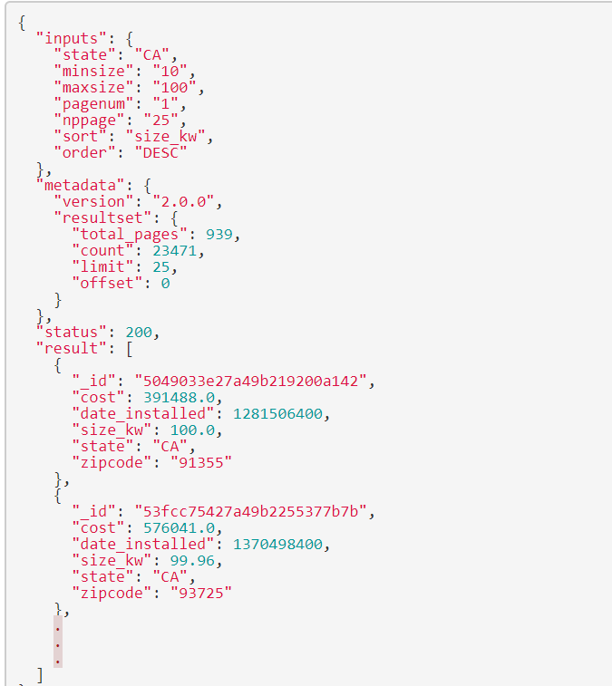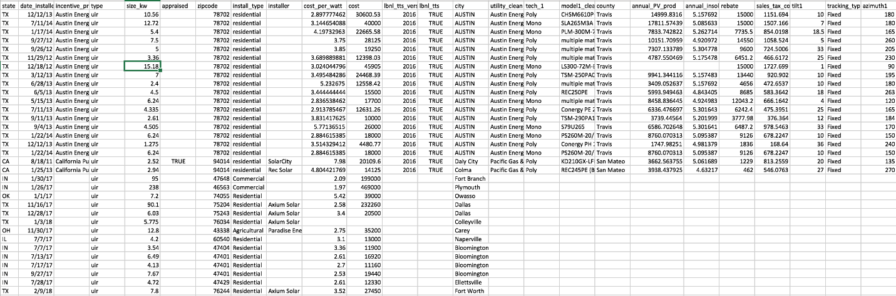

1. Energy Information Agency (EIA): Average electricity price by state and end use sector. <https://www.eia.gov/electricity/monthly/epm_table_grapher.php?t=epmt_5_6_a>

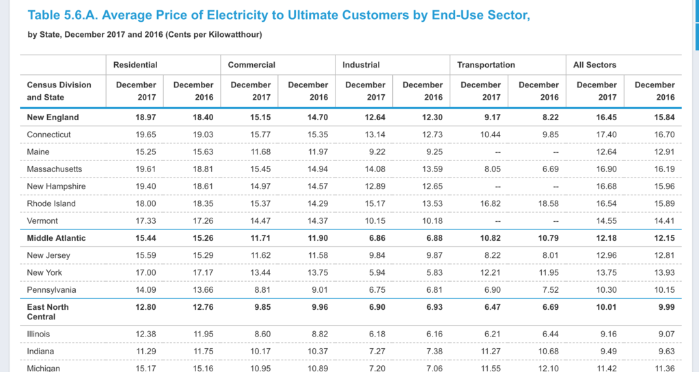

1. 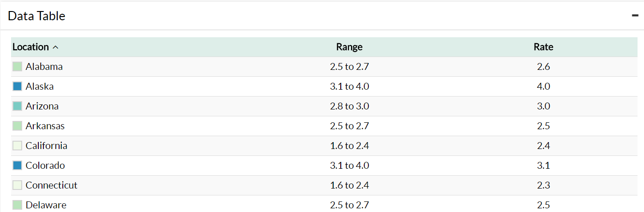Center for Disease Control and Prevention (CDC): Skin cancer rates and melanoma mortality rates by state. <https://www.cdc.gov/cancer/skin/statistics/state.htm>

**Inspiring Visualizations**

Layered heat map (intent is to provide layer control via Leaflet)

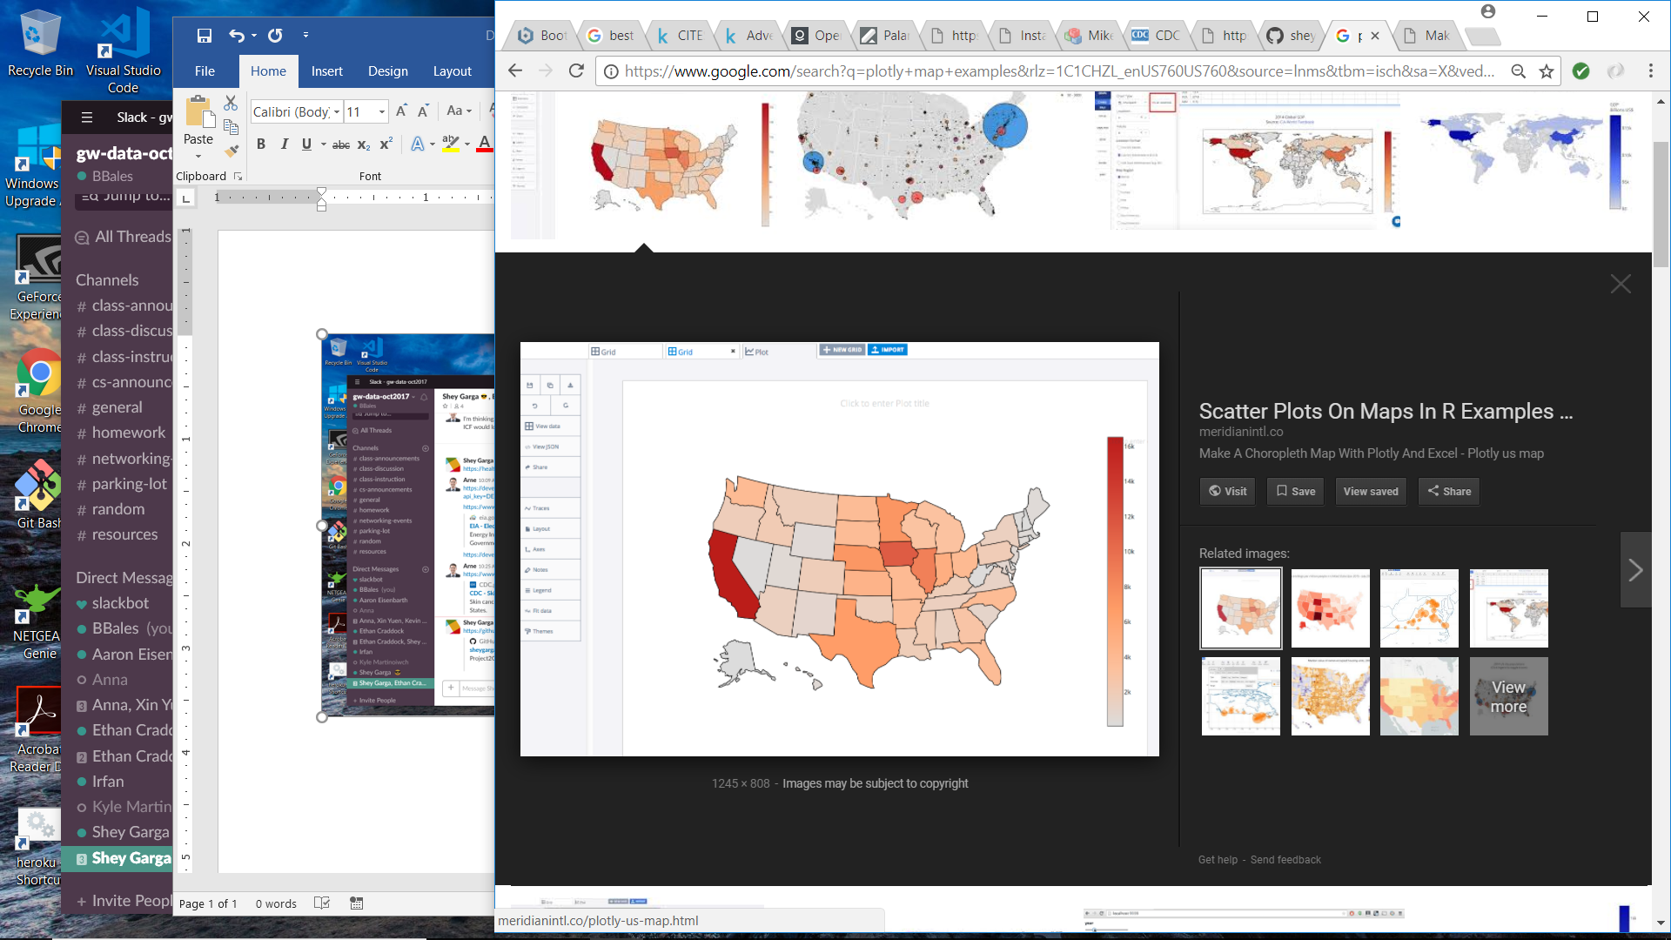

Scatterplot (via Plotly)

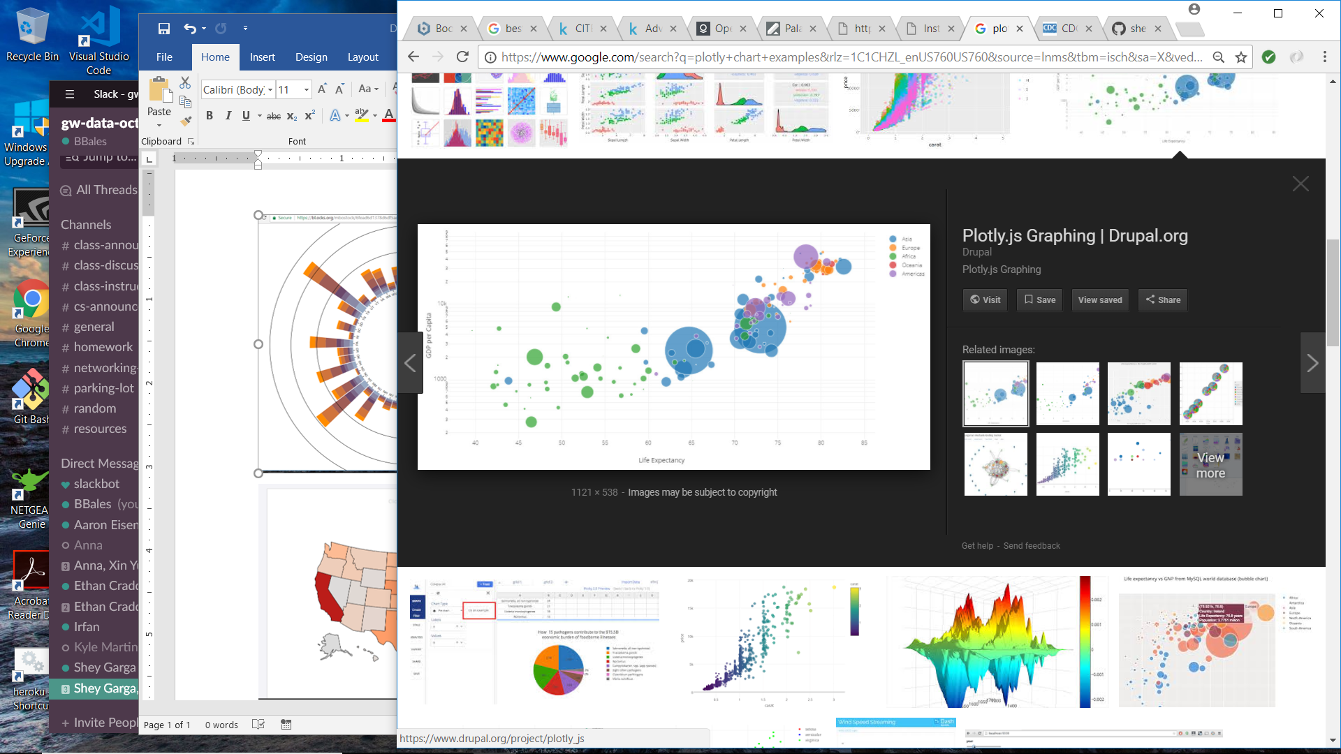

“Sun-inspired” radial stacked bar:

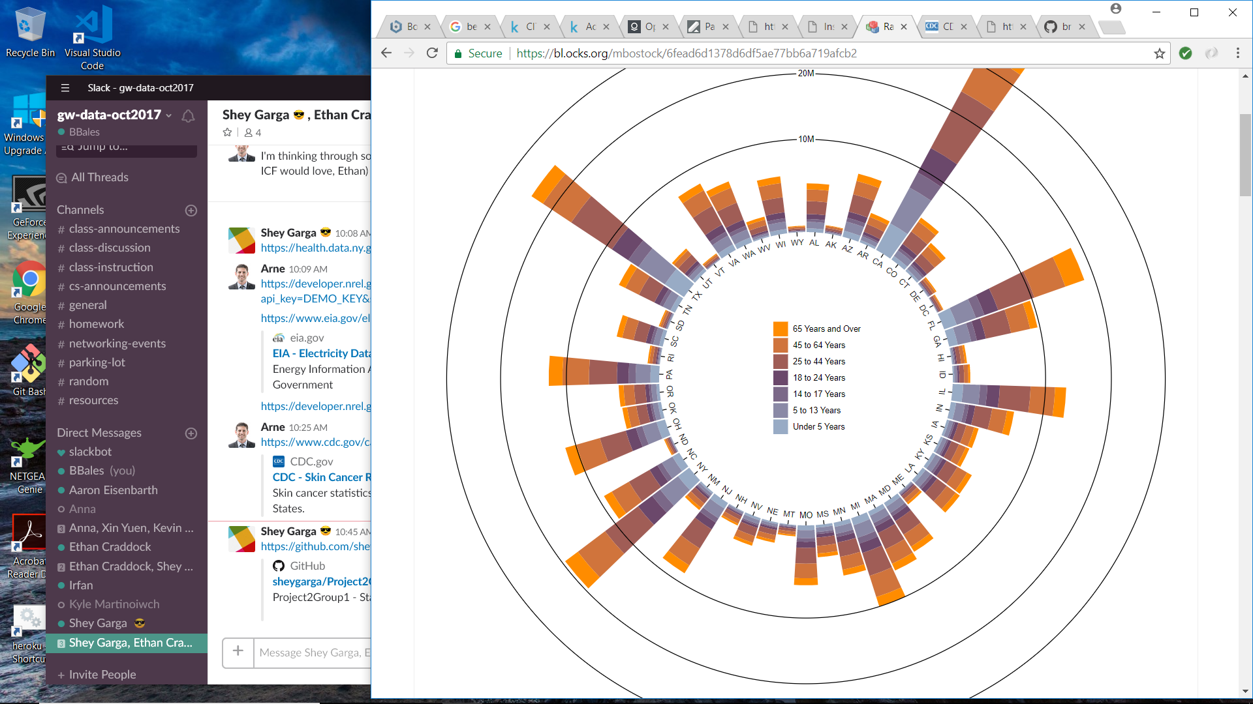

**Final Design Sketch**